AI Assignment Report

Kirsten Speirs and Aya Hammad

**Hill-climbing Algorithm**

We decided to use the inversion operator to create a random neighbour for the hill-climbing algorithm. Doing this allowed us to get a wide range of different solutions to be compared.

List of values plotted:

100:

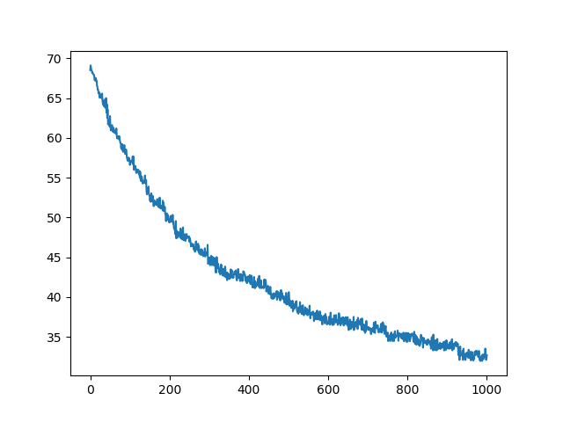

Time elapsed: 0.39s

Solution: 

500:

Plot: 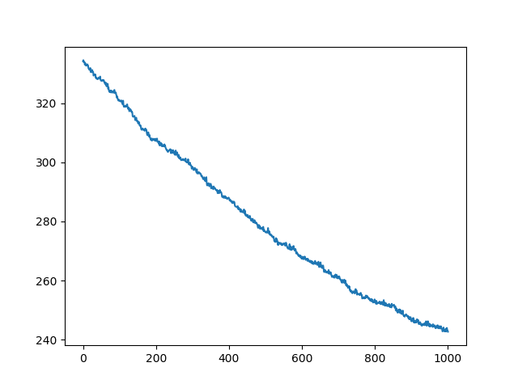

Time elapsed: 1.31s

Solution:



**Multi-start Hill-climbing Algorithm**

**For sample size 100**

Individual means: [33.76390885854582, 32.8886573786058, 31.882869316359777, 31.978958132052348, 34.004060322233535, 33.92154025729911, 31.08627500626907, 31.702246493240377, 33.28035418336438, 31.8455864826292, 30.29007904907861, 30.89425424782643, 31.00468804763709, 32.858366817445, 32.34341721114464, 31.69640628390975, 31.61974666208652, 31.62423533206043, 31.784144635515617, 31.369342512155878, 32.64825811089249, 30.793762445997114, 32.02693630509632, 30.006020856186694, 31.96897985853824, 32.68923734908215, 31.389052797261837, 33.62324731658264, 29.954191355064683, 30.526526250932527

Total mean: 31.915511662503135

Individual medians: 33.76390885854582, 32.8886573786058, 31.882869316359777, 31.978958132052348, 34.004060322233535, 33.92154025729911, 31.08627500626907, 31.702246493240377, 33.28035418336438, 31.8455864826292, 30.29007904907861, 30.89425424782643, 31.00468804763709, 32.858366817445, 32.34341721114464, 31.69640628390975, 31.61974666208652, 31.62423533206043, 31.784144635515617, 31.369342512155878, 32.64825811089249, 30.793762445997114, 32.02693630509632, 30.006020856186694, 31.96897985853824, 32.68923734908215, 31.389052797261837, 33.62324731658264, 29.954191355064683, 30.526526250932527

Total median: 31.81486555907241

Standard deviation: 1.1030732830583851

Best solution plotted:

Time Elapsed: 6.27s

Objective function value: 29.954191355064683

**For sample size 500**

Individual means: [236.23159486804704, 239.06663262667553, 235.27330108074966, 240.8565074891396, 241.96728301068066, 241.3495677987697, 236.81312135991382, 238.92471036177955, 239.2907384745879, 237.55044264193674, 238.6089149388227, 231.66766687903853, 240.5797055722087, 234.93846176440707, 238.17808260964662, 243.90251545094515, 242.9338032727347, 232.26252491293369, 239.09532253903572, 240.52176922698678, 241.43024650984896, 235.5064964842251, 247.0508273081225, 240.10030414458362, 235.6833700724749, 246.6682934501955, 238.0839595469636, 232.34552188915822, 233.03767678710315, 237.99180137513773]

Total mean: 238.59703881489511

Individual medians: [236.23159486804704, 239.06663262667553, 235.27330108074966, 240.8565074891396, 241.96728301068066, 241.3495677987697, 236.81312135991382, 238.92471036177955, 239.2907384745879, 237.55044264193674, 238.6089149388227, 231.66766687903853, 240.5797055722087, 234.93846176440707, 238.17808260964662, 243.90251545094515, 242.9338032727347, 232.26252491293369, 239.09532253903572, 240.52176922698678, 241.43024650984896, 235.5064964842251, 247.0508273081225, 240.10030414458362, 235.6833700724749, 246.6682934501955, 238.0839595469636, 232.34552188915822, 233.03767678710315, 237.99180137513773]

Total median: 238.76681265030112

Standard deviation: 3.8204237373114758

Best plotted:



Time elapsed: 29.21s

Objective function value: 233.03767678710315